Exercises

**Q1. Consider a database LOANS with the following tuples:**

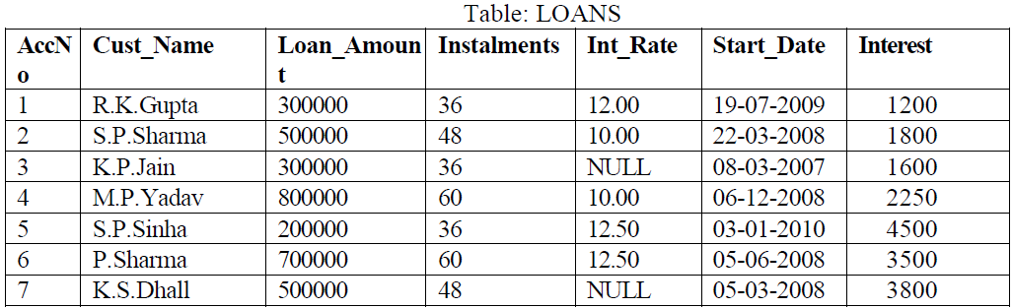

1. Create the table Loans and insert tuples in it.

create table loans (AccNo integer, Cust_Name varchar(25),Loan_Amount number,Instalments number,int_rate float,Start_date date, Interest number);

insert into loans values(&Acno,’&Name’,&Amount,&Instalments,&intrate’&date’,&interest);

1. Display the details of all the loans.

select *from loans;

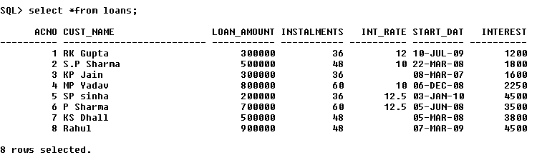

1. Display the AccNo, Cust_Name, and Loan_Amount of all the loans.

select ACNO,CUST_NAME, LOAN_AMOUNT from loans;

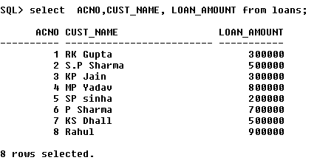

Conditional Select using Where Clause

1. Display the details of all the loans with less than 40 instalments.

select *from loans where instalments<40;

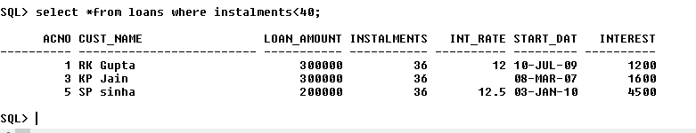

1. Display the AccNo and Loan_Amount of all the loans started before 01-04-2009.

select ACNO,LOAN_AMOUNT from loans where start_date<'01-APR-09';

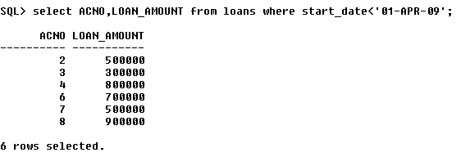

1. Display the Int_Rate of all the loans started after 01-04-2009.

select int_rate from loans where start_date>'01-APR-09';

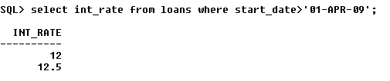

Using NULL

1. Display the details of all the loans whose rate of interest is NULL.

select *from loans where int_rate is NULL;

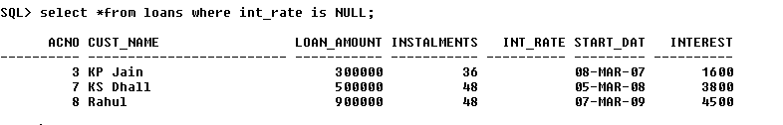

1. Display the details of all the loans whose rate of interest is not NULL.

select *from loans where int_rate is NOT NULL;

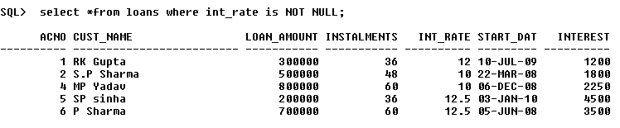

Using DISTINCT Clause

1. Display the amounts of various loans from the table LOANS. A loan amount should appear only once.

select distinct loan_amount from loans;

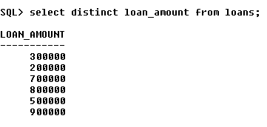

1. Display the number of installments of various loans from the table LOANS. An instalment should appear only once.

select distinct instalments from loans;

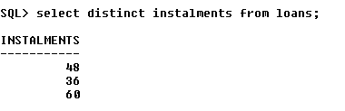

Using Logical Operators (NOT, AND, OR) and Between

1. Display the details of all the loans started after 31-12-2008 for which the number of instalments are more than 36.

select *from loans where start_date>'31dec08' and instalments>36;

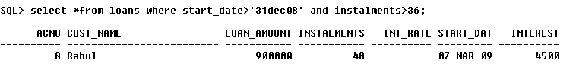

1. Display the Cust_Name and Loan_Amount for all the loans which do not have number of instalments 36.

select CUST_NAME, LOAN_AMOUNT from loans where not(instalments=36);

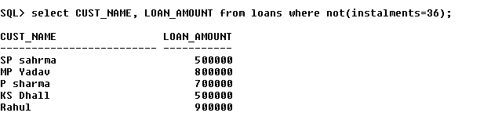

1. Display the Cust_Name and Loan_Amount for all the loans for which the loan amount is less than 500000 or int_rate is more than 12.

select CUST_NAME, LOAN_AMOUNT from loans where (LOAN_AMOUNT<500000 or INT_RATE>12);

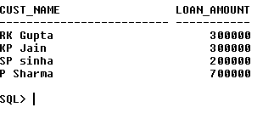

1. Display the details of all the loans whose Loan_Amount is in the range 400000 to 500000.

select *from loans where loan_amount between 400000 and 500000;

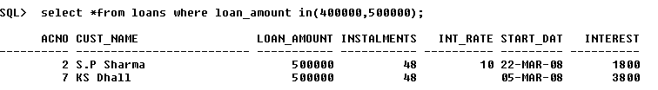

1. Display the details of all the loans whose rate of interest is in the range 11% to 12%.

select *from loans where INT_RATE between 11 and 12;

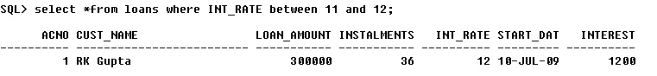

Using IN Operator

1. Display the Cust_Name and Loan_Amount for all the loans for which the number of installments are 24, 36, or 48. (Using IN operator)

select CUST_NAME, LOAN_AMOUNT from loans where INSTALMENTS in (24,36,48);

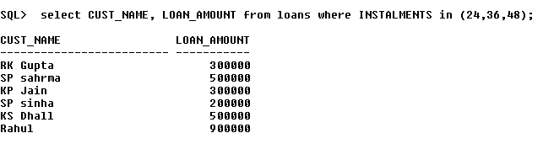

Using LIKE Operator

1. Display the AccNo, Cust_Name, and Loan_Amount for all the loans for which the Cust_Name ends with 'Sharma'.

select ACNO,CUST_NAME, LOAN_AMOUNT from loans where CUST_NAME like '%Sharma';

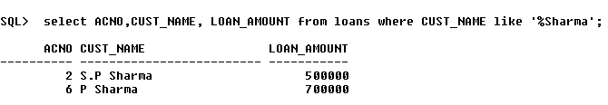

1. Display the AccNo, Cust_Name, and Loan_Amount for all the loans for which the Cust_Name ends with 'a'.

select ACNO,CUST_NAME, LOAN_AMOUNT from loans where CUST_NAME like '%a’;

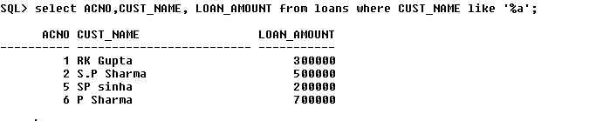

1. Display the AccNo, Cust_Name, and Loan_Amount for all the loans for which the Cust_Name contains 'a'.

select ACNO,CUST_NAME, LOAN_AMOUNT from loans where CUST_NAME like '%a%';

se;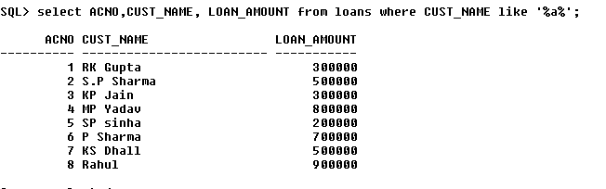

1. Display the AccNo, Cust_Name, and Loan_Amount for all the loans for which the Cust_Name does not contain 'P'.

select ACNO,CUST_NAME, LOAN_AMOUNT from loans where not (CUST_NAME like '%P%');

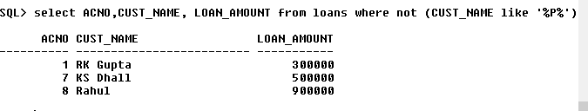

1. Display the AccNo, Cust_Name, and Loan_Amount for all the loans for which the Cust_Name contains 'a' as the second last character.

select ACNO,CUST_NAME, LOAN_AMOUNT from loans where CUST_NAME like '%a_';

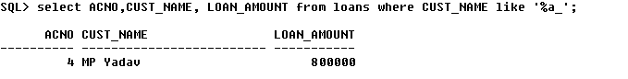

Using ORDER BY clause

1. Display the details of all the loans in the ascending order of their Loan_Amount.

select *from loans ORDER BY LOAN_AMOUNT ASC;

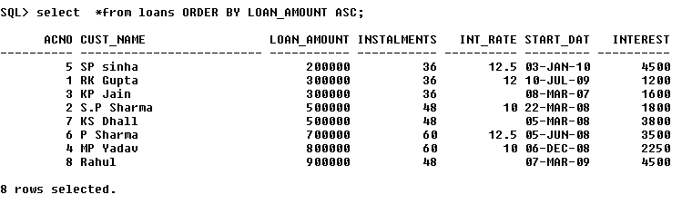

1. Display the details of all the loans in the descending order of their Start_Date.

select *from loans ORDER BY start_date DESC;

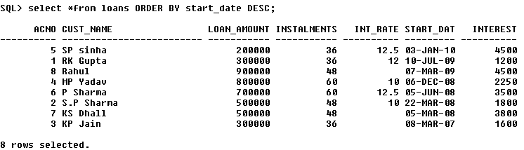

Using UPDATE, DELETE, ALTER TABLE

1. Put the interest rate 11.50% for all the loans for which interest rate is NULL.

update loans set int_rate=11.50 where int_rate is NULL;

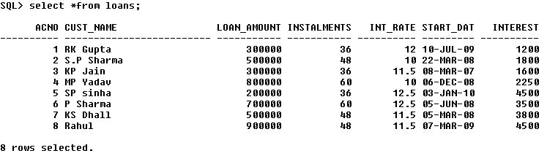

1. Increase the interest rate by 0.5% for all the loans for which the loan amount is more than 400000.

update loans set int_rate=int_rate+0.5 where loan_amount>400000;

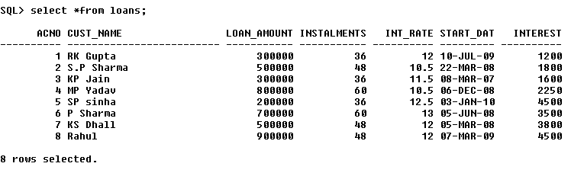

1. For each loan replace Interest with (Loan_Amount*Int_Rate*Instalments) /12*100.

update loans set interest=(LOAN_AMOUNT*INT_RATE*INSTALMENTS)/12*100;

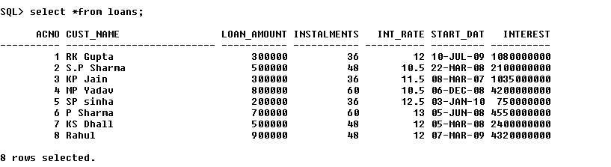

1. Delete the records of all the loans of 'K.P. Jain'

delete from loans where cust_name='KP Jain';

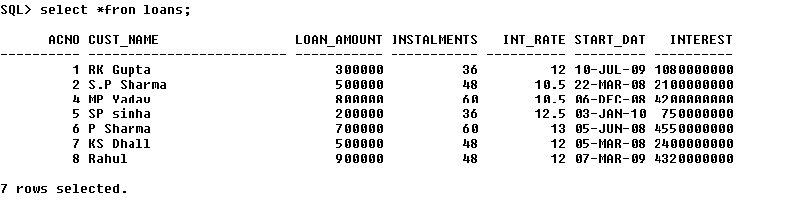

1. Add another column Category of type CHAR(1) in the Loan table.

alter table loans add category char(1);

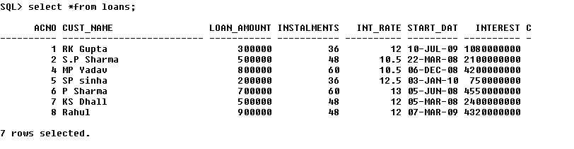

Using Aggregate Functions

1. Display the sum of all Loan Amount for whose Interest rate is greater than 10.

select sum(loan_amount) from loans where int_rate>10;

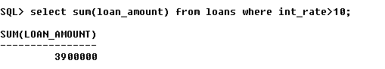

1. Display the Maximum Interest from Loans table.

select max(interest) from loans;

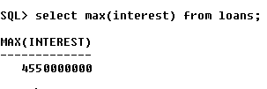

1. Display the count of all loan holders whose name is ending with ‘Sharma’.

Select count(*) from loans where cust_name like ‘%Sharma%’;

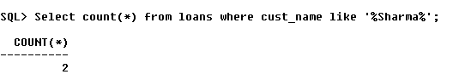

1. Display the count of all loan holders whose Interest is Null.

Select count(*) from loans where interest is null;

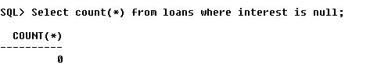

Using Group By Clause

1. Display the Interest wise details of Loan Account Holders.

select cust_name,interest from loans group by interest, cust_name;

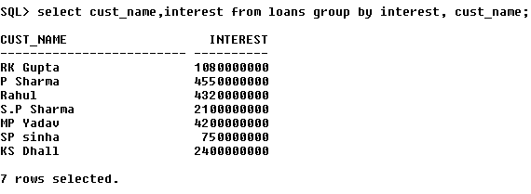

1. Display the Interest wise details of Loan Account Holders with at least 10 installments remaining.

select cust_name,interest,instalments from loans group by interest,cust_name,instalments having instalments>=10;

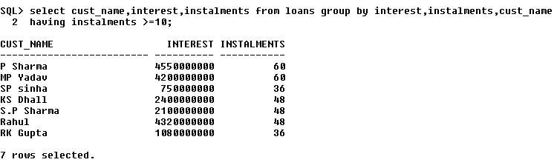

1. Display the Interest wise count of all loan holders whose Installment due is more than 5 in each group.

select count(interest),instalments,cust_name from loans group by interest,instalments,cust_name having instalments>5;

